PSU simulation and PCB design
Justification:
I’ve decided to take my single rail 12V transformer based power supply ahead notably for the suspiciously high simulated efficiency I’ve been getting but also for variety on the team’s behalf for our power supplies. Out of all the PSUs I simulated and researched (more information within my logbook), this one interested me the most design-wise, as I found many useful resources deconstructing how each “segment” of the circuit worked in ultimately converting the 265V AC to 12V DC.
Note for report: this doesn’t include circuitry for voltage conversions later on (e.g., does not include voltage regulators converting to 3.3V for Il Matto).
Researched and Simulated PSUs:
Power Supply Type | Efficiency, % (taking most efficient design)
Transformer Based | 69.074
Charge Pump | 1.704
Capacitor Dropper | 21.493

As evident from the results table above, the transformer was significanty more efficient and although I’m skeptical as to the legitimacy of that value, I feel confident in my understanding of its design and how it works.
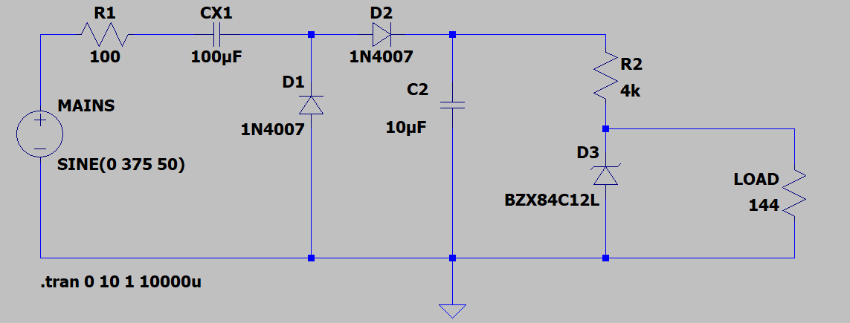
For the different PSU type, I redesigned & tested each using a linear regulator versus a zener diode. I found that the stocked 12V voltage regulators resulted in a higher efficiency compared to other methods so doubled down on using one for my transformer design.

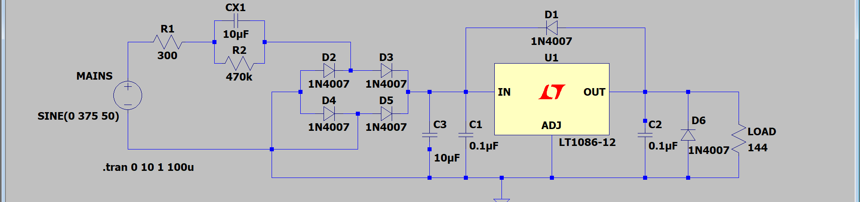
Figure 1Charge pump and capacitor dropper designs
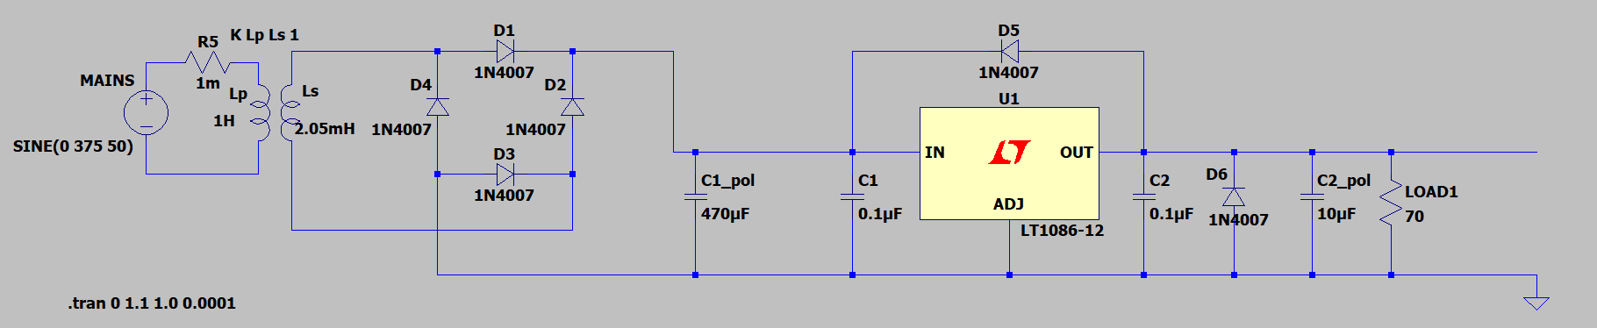
Simulation Results:
Figure 3 Voltage Output for 100ohm resistor
Figure 2 Final PSU LTspice Schematic
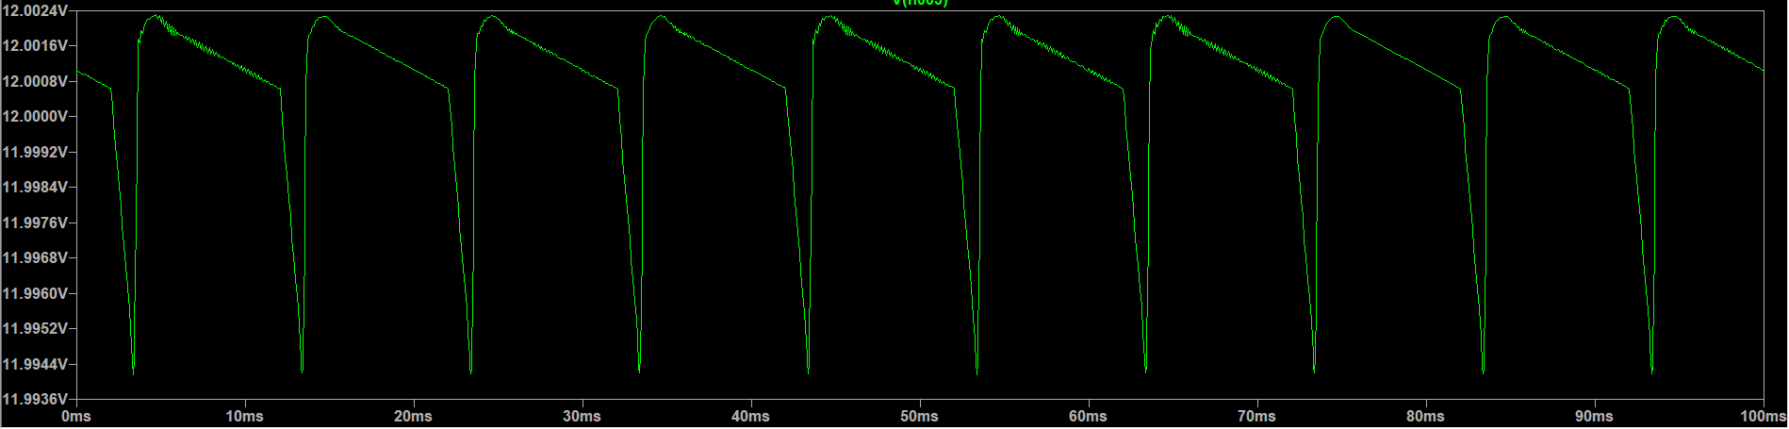
Simulation results provided a very constitent voltage up until a load of about 90ohms (which is the equivalent of the Il Matto and screen drawing 133mA of current) with, for reference, 70ohms (171mA current) leading to +/- 0.25V about 11.75V. The significance of this is as follows: my PSU needs to be able to draw enough current to power the Il Matto and LCD screen without seeing unstable changes to the outputted voltage. To ensure this won’t occur when my PSU is operating, I need to simulate for the most extreme case of current drawn by the system. The Il Matto relative to the TFT screen will draw much less current (less than 10mA) with the LCD being split between logic (only 5mA) and the backlight (around 100mA). Given this is under the most extreme conditions for the system (max brightness of the LCD, etc) and that I have about 15mA for the interface circuitry until my 12V output becomes unstable, I’m confident in my PSU’s ability to manage under stress during normal operation of the Smart Meter – also considering LCD settings can be altered to accommodate if necessary.
According to the handbook, for my given configuration a144ohm load resistor can simulate the controller, LCD and interface circuitry giving a 1W total load power consumption. This reference gives me 68.9% efficiency and draws 83mA of current giving me a 50mA safety net for sudden spikes in system demand (and also it’s important to note for that extreme case of a 90ohm load, my PSU still keeps the power consumption under 2W at about 1.6W).
PCB Design and Assembly:
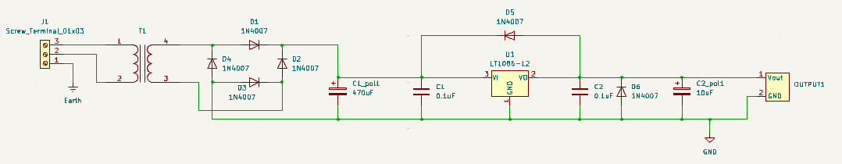
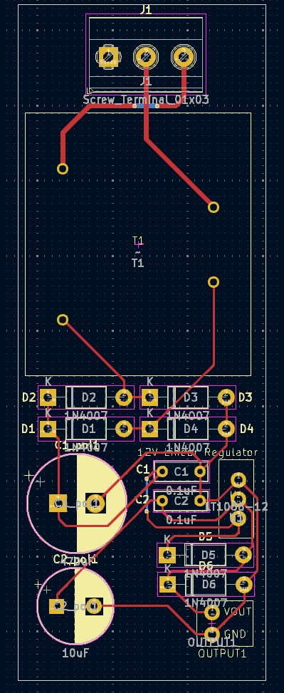
Using KiCad, I recreated the schematic for my design using the exact same component labels so that post-assembly I would be able to accurately decipher which part was which. Also, the design itself was slightly tweaked now that I was past the simulation stage (important considering polarised capacitors would have been irrelevant for simulation but paramount for actual operation) and added in the connections for both the mains and output side. Custom footprints were also created for some components.
Figure 5 KiCad Schematic of PSU (includes custom footprints)
Figure 4 PCB Layout of Transformer-based PSU
Dimensions were determined based off component datasheets found either through given parts (like the 1N4007 diode) or through datasheets of the ECS labs more basic and stocked components I found online (the regular capacitors etc). The total PCB falls within the dimensions limit for the isolated PSU compartment of our box (98mm x 36.5mm x 44mm) with at least a few mm of freedom in every dimension. Alongside this relevant design features were implemented like wider tracks on the mains side of the transformer, etc.
The design is mostly comprised exclusively of lab-stocked components, bar the transformer (which I’ll expand on in the following section) and was also the largest component which just fit onto the board again with some mm of room either side.
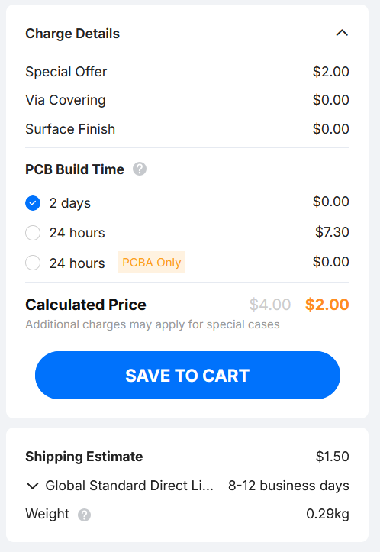
Purchase & Costs:
Figure 6 Pricing estimation from JLPCB

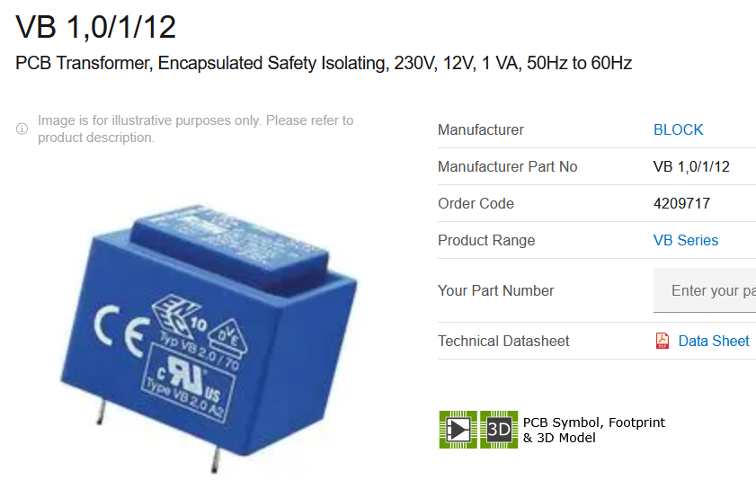
Figure 7 PCB transformer used in design (not final)

All the required files for my PCB have been attached and following the listed instructions for price estimation on Moodle, I’ve found the board should cost under $4 shipping included (I believe the currency conversion feature was removed from the website).
My PCB has been finalised; however, I have encountered one significant issue. All the PCB transformers found on ECS-approved component websites (Farnell, RS, etc) have had many PCB transformers for 230V AC step down at 50Hz, but I was unable to find any that were able to operate with the 265V AC of the Test Bed, except for transformers that were specifically designed for SMPS and paired with other ICs. All my simulations have been done for the 265V mains, however, I’ve designed the PCB using a 230V transformer’s specification (https://uk.farnell.com/block/vb-1-0-1-12/xfmr-1va-safety-isolating-th/dp/4209717). So, the next step for me is getting into contact with the technicians to see if I can find somewhere to buy a 50Hz PCB transformer that can convert 265V to 12V, before the deadline next week for any PSU-related orders.
That said, in terms of PCB design, changing the transformer would not take much effort other than altering the overall dimensions and the through-holes. Additionally, I’ve seen the box physically in person and after measuring it manually (to be sure), this board when printed will indeed fit within its allotted compartment.

